Video

Class vii

Lab 23

**Lab Objectives:**

* Making an introduction video about yourself

Introduction

Who are you?

Which class do you read in?

What is the name of your school?

What do you want to be?

Do you love your country?

The answers of these questions are the reflection of yourself. Today you are going to make a video about yourself using MS PowerPoint.

Making “About Me” Video

Let’s open an empty slide. Go to design menu and choose one of your favorite designs.

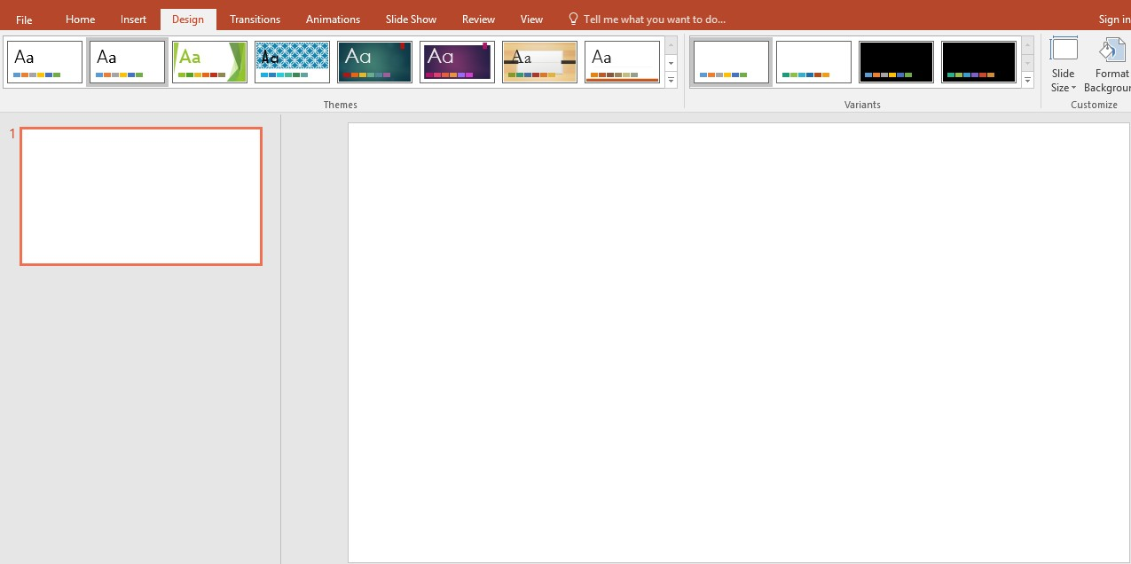

your background will be changed.

Select textbox and write “Hello Everyone!”

Select another textbox and write your name.

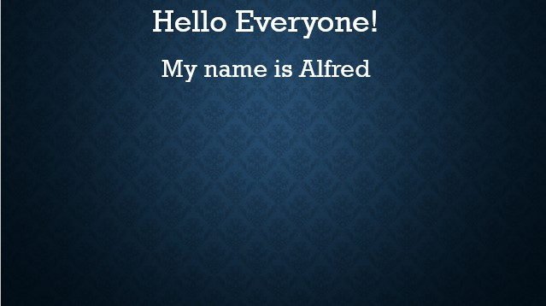

Like this, chose one after another text box and write all of the following text.



Mark all the item by pressing Ctrl+A and go to animation option and click on Float in

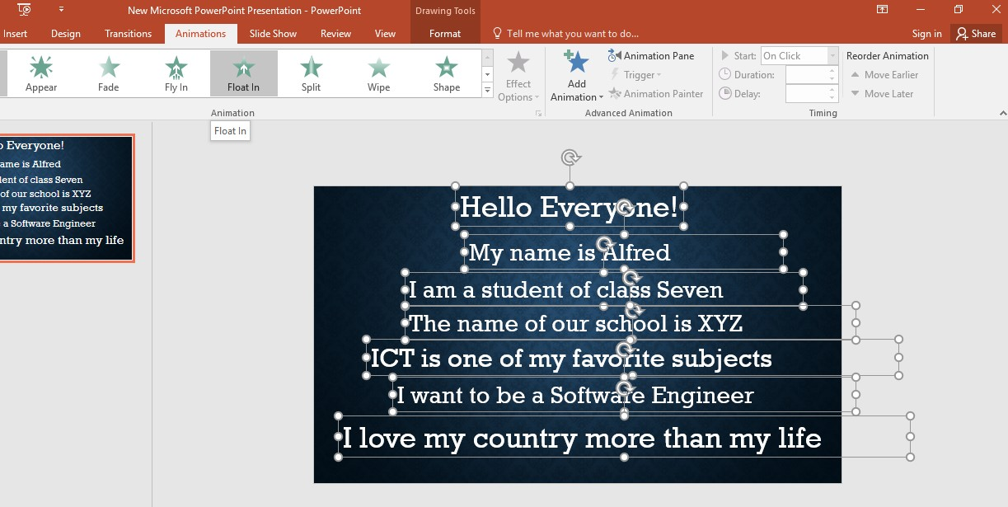

Now click on first text box and change the setting as above.

Start: With Previous

Duration: 03.00

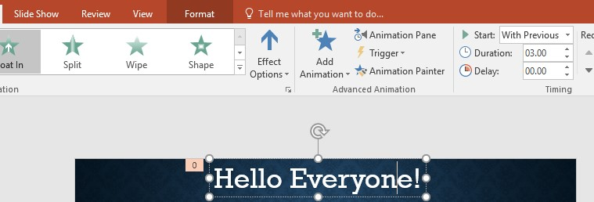Delay: 00.00

Click on 2nd text box and change the setting

Start: With Previous

Duration: 03.00

Delay: 06.00

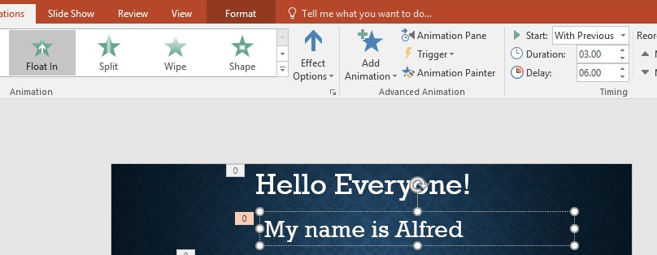

Duration refers to time limit of showing the animated text. 3 sec duration means your text will be moving like Float in for 3 second. Delay 00.00 means after opening the video animation will start from 0 sec. In 2nd text with set the delay for 6 sec. It means your 2nd text will be appeared after 6 seconds from the 1st one. If we set the delay: 09.00, 12.00, 15.00, 18.00 sec for rest of the text, the rest of text will appear one after another with a delay of 9,12,15,18 second from the first one.

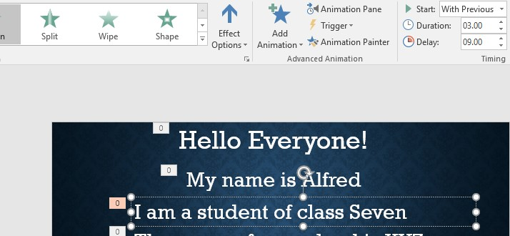Let’s do that.

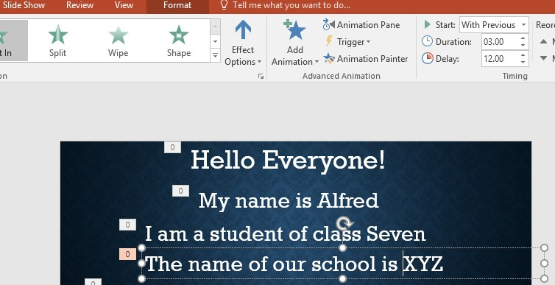

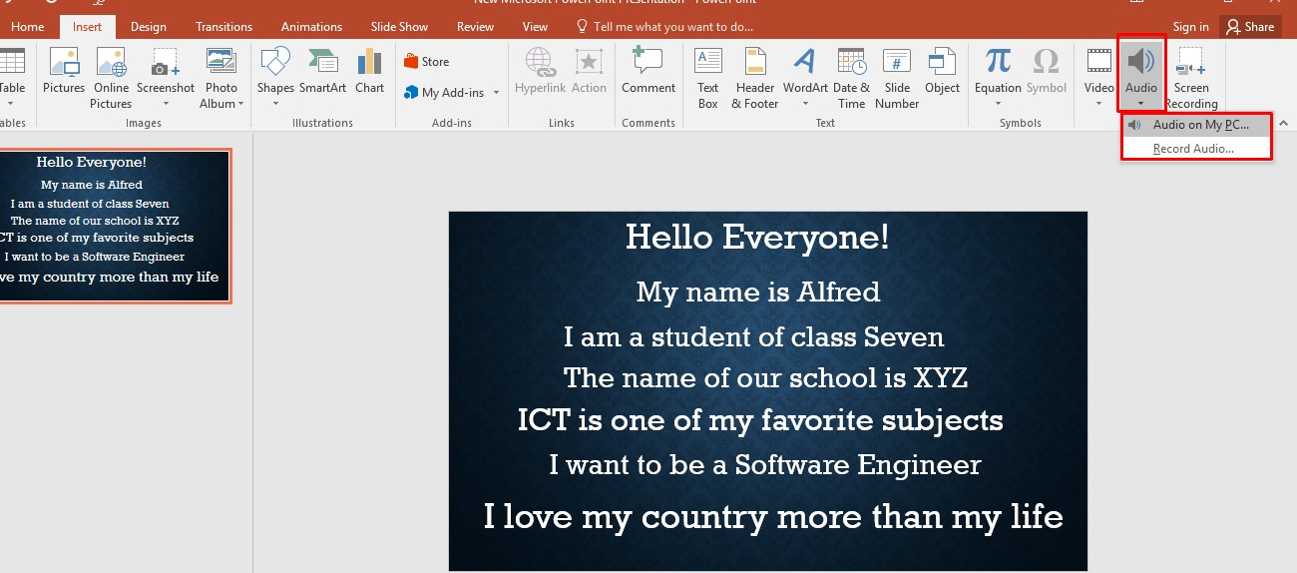After doing all of this, go to insert and click on audio. Then click on audio on my pc.

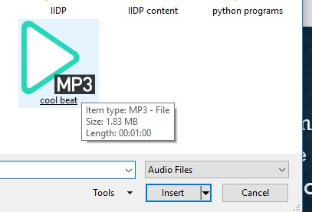I have selected and audio mp3 file from my computer

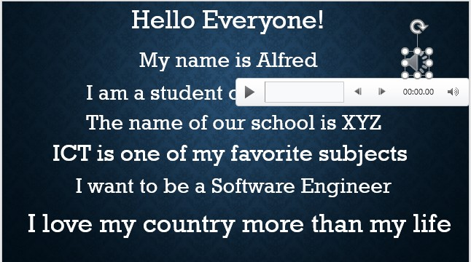That audio file will be attached with your slide.

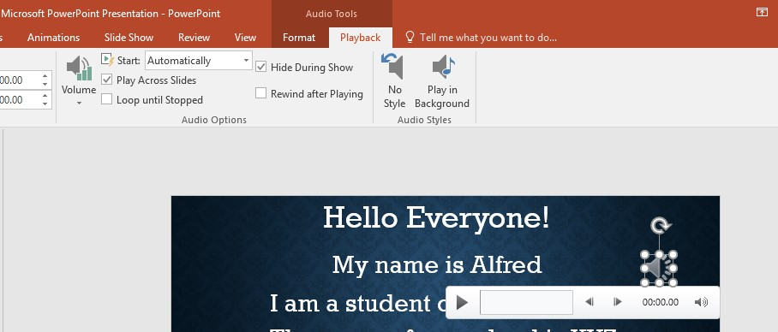Change the setting of audio as shown in picture.

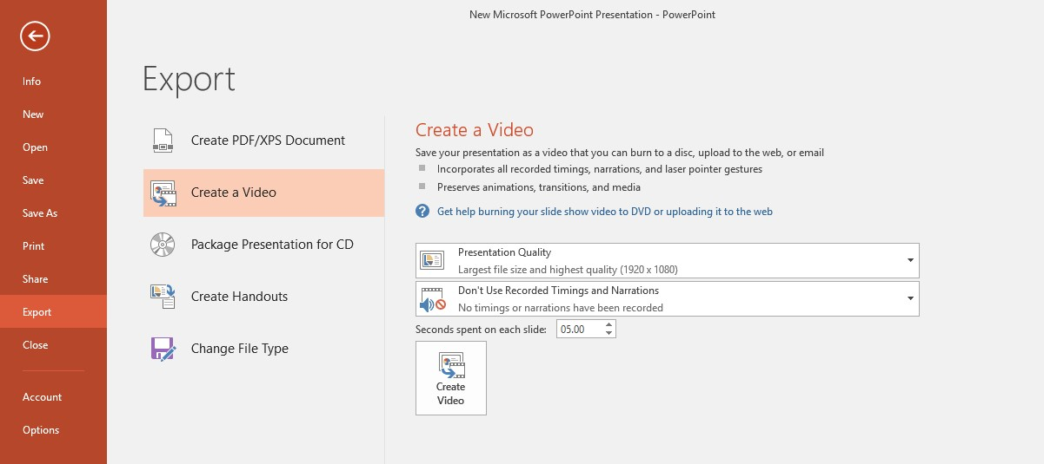Export as a video.

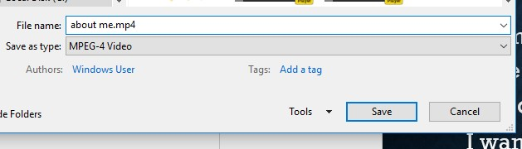

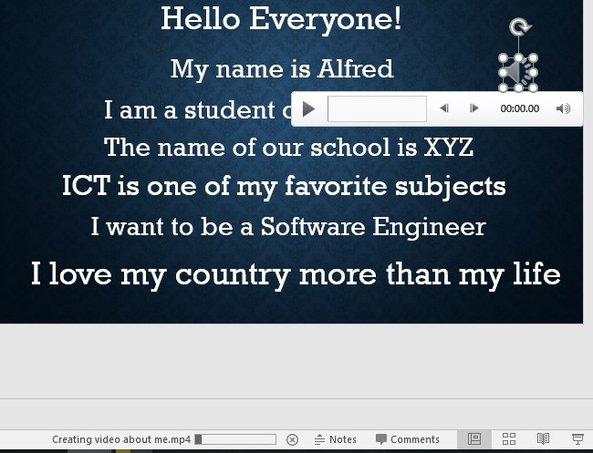Wait few seconds for rendering the video.

After completion of loading you will be able to play the video from your computer.